### *University of Pittsburgh*

### *School of Computing and Information*

# INFSCI 2750: Cloud Computing

# Spring 2020

**Mini Project 2**



**Submitted by:**

|  |  |  |
| --- | --- | --- |
| **SL. No.** | **Name** | **Email address** |
| 1 | Debdas Ghosh | deg107@pitt.edu |
| 2 | Piu Mallick | pim16@pitt.edu |

**Objective**

The objective of this mini project is to get familiarized with Apache Spark.

**Part 1: Setting up Spark**

The first task is to configure **Spark distribution** on top of the **previously installed Hadoop cluster** (already done for Mini Project 1).

**Recap of previously set-up Hadoop cluster:**

As a part of Mini Project 1, we had set-up Hadoop on the VMs. Each member of our team was assigned a VM, on which we installed and ran Hadoop. As the first step of our project, we made sure that Hadoop is set up properly on each of the VMs assigned to all the team members by running single node set up. Then, at the second step, we proceeded towards setting a 3-node cluster, with the assistance of the tutorial provided.

**Segregating the 3 VMs as Master & Slaves:**

|  |  |  |
| --- | --- | --- |
| **VM Type** | **IP Address** | **VM Name** |
| Master | 134.209.160.211 | CC-MON-25 |
| Slave 1 | 64.225.17.118 | CC-MON-26 |
| Slave 2 | 138.197.96.66 | CC-MON-27 |

**Screenshots showing cluster set-up and active status of the nodes**

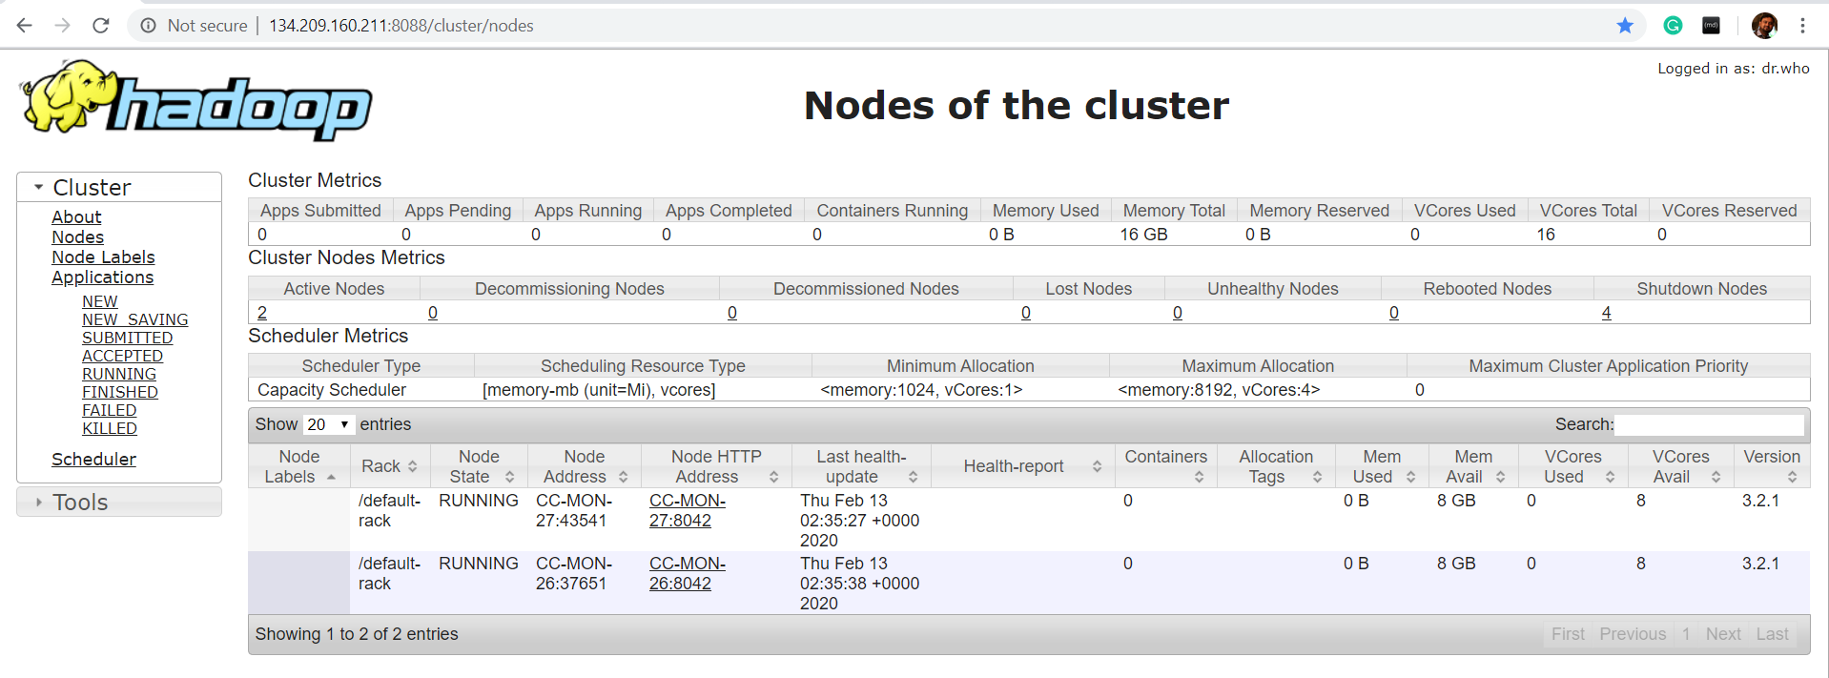

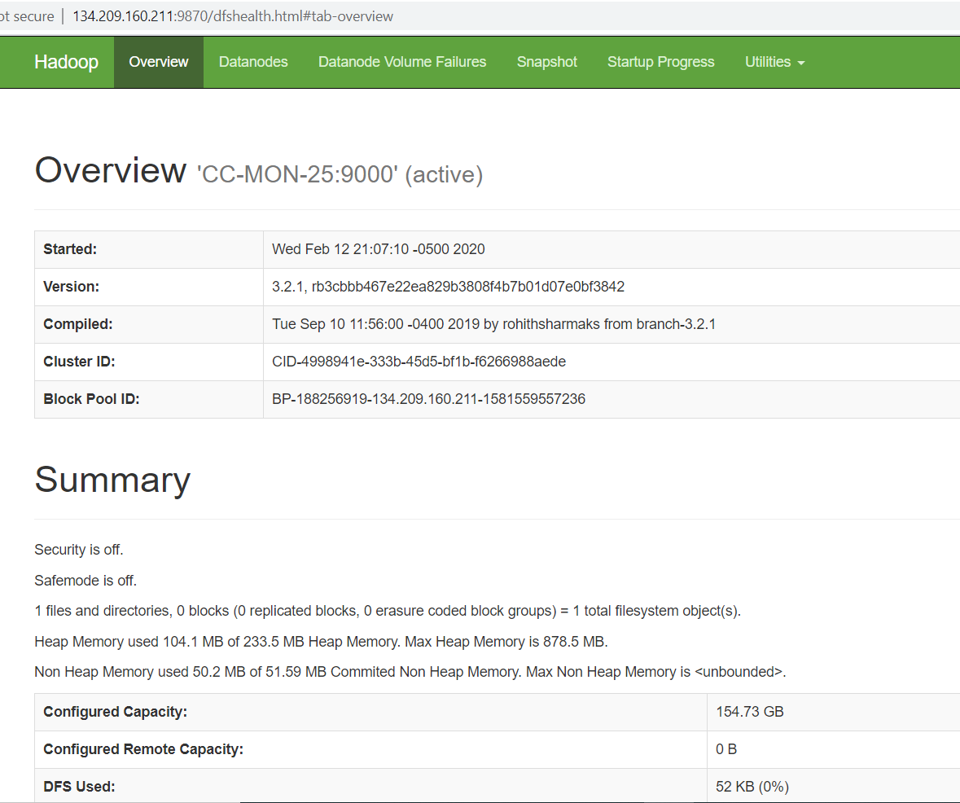

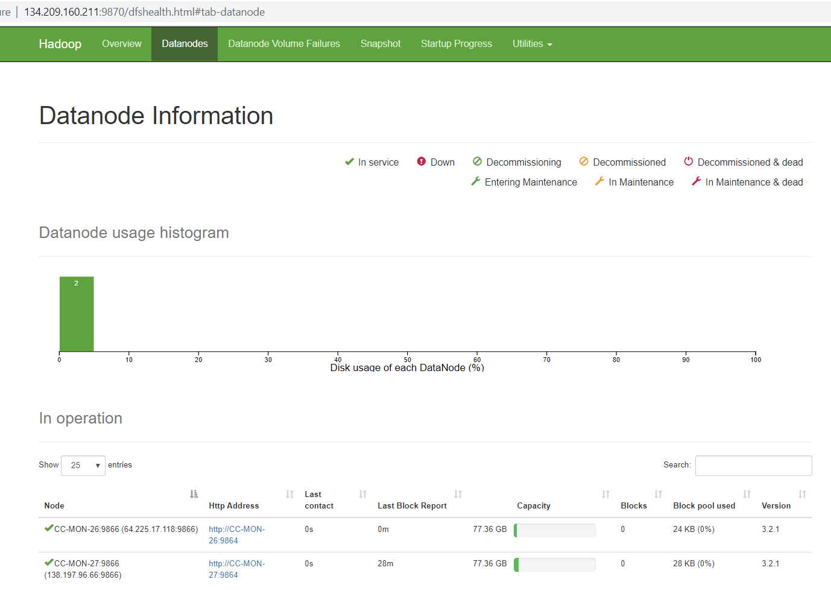

The ‘**jps**’ command is also executed (in Master as well as the slaves to check whether Hadoop is running properly):

**Master CC-MON-25:**

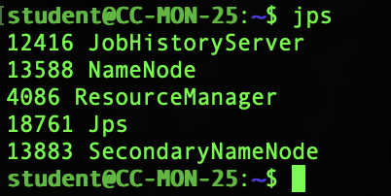

**Slave CC-MON-26:**

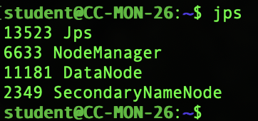

**Slave CC-MON-27:**

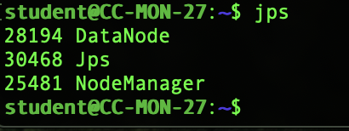

The set-up makes use of YARN for scheduling/running Spark applications.

The entire Spark set-up is configured on top of a three-node Hadoop cluster.

**Master: CC-MON-25**

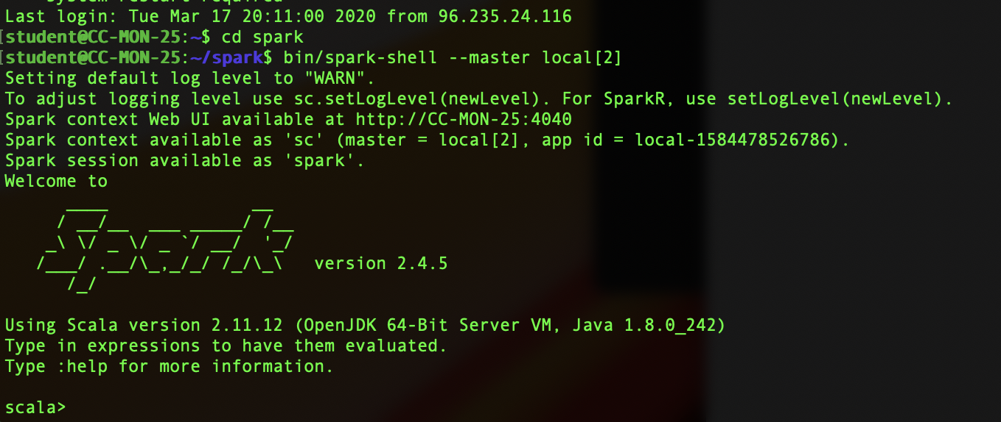

**Slave 1: CC-MON-26**

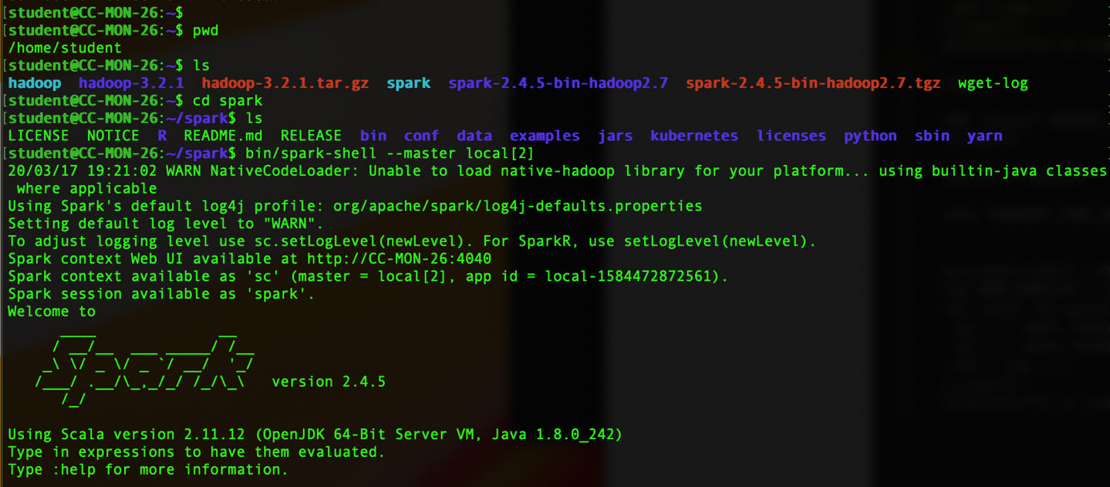

**Slave 2: CC-MON-27**

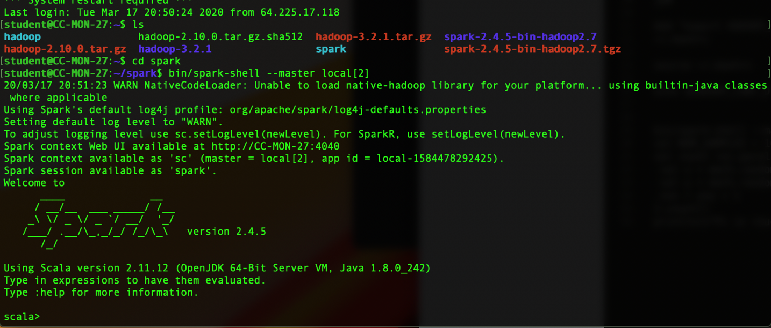

The following command is executed to check whether Spark is running in the master as well as the slaves:

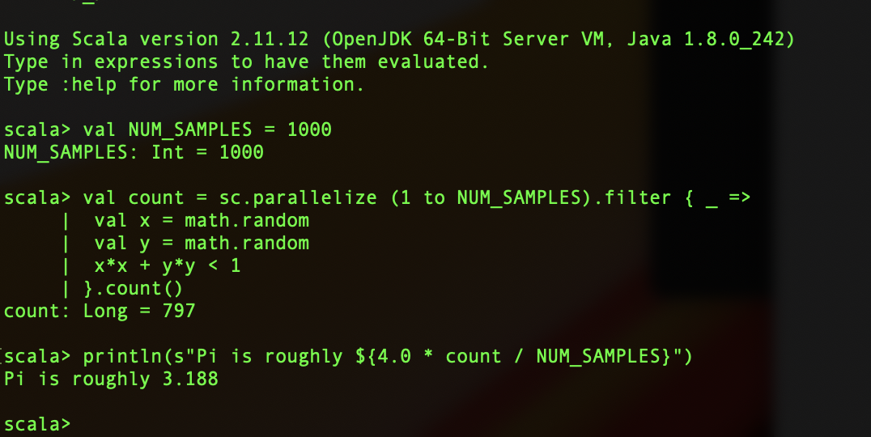

And, we get proper results which ensures that Spark is up and running.

Another example:

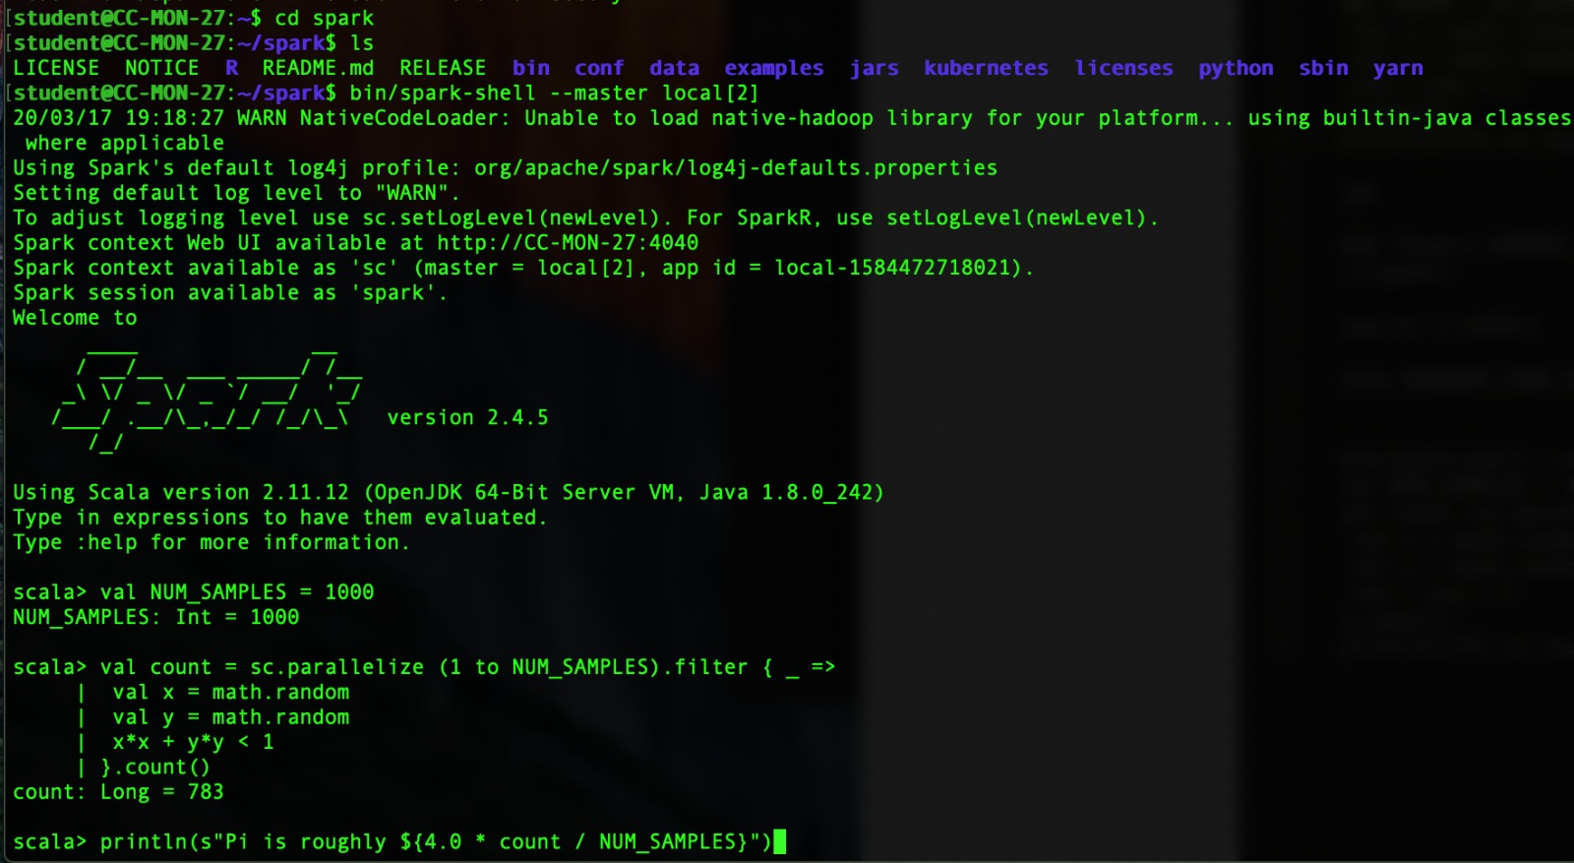

**Integration with YARN:**

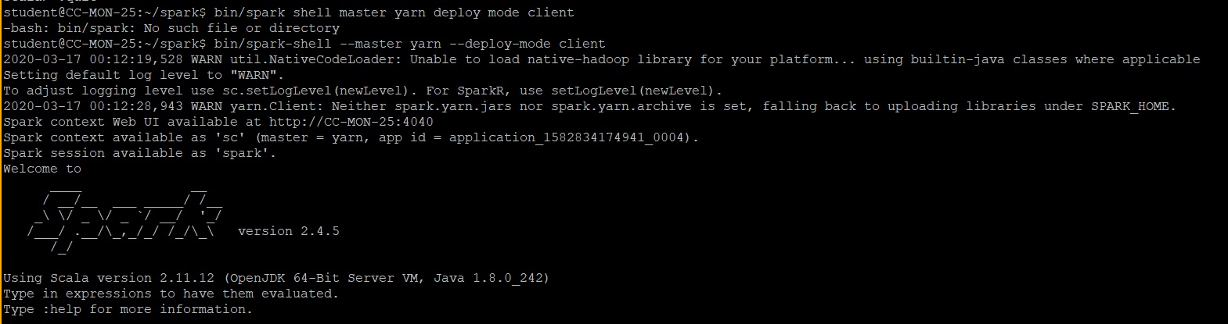

**Example:**

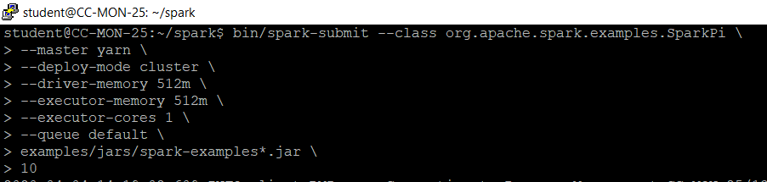

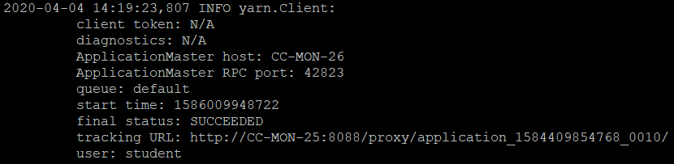

Package and Run Sample Spark Java Program:

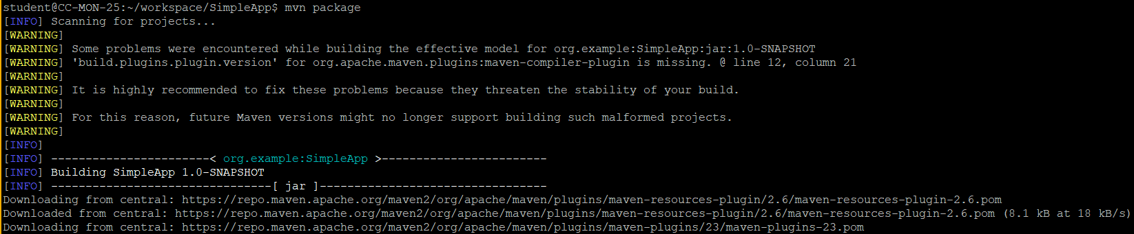

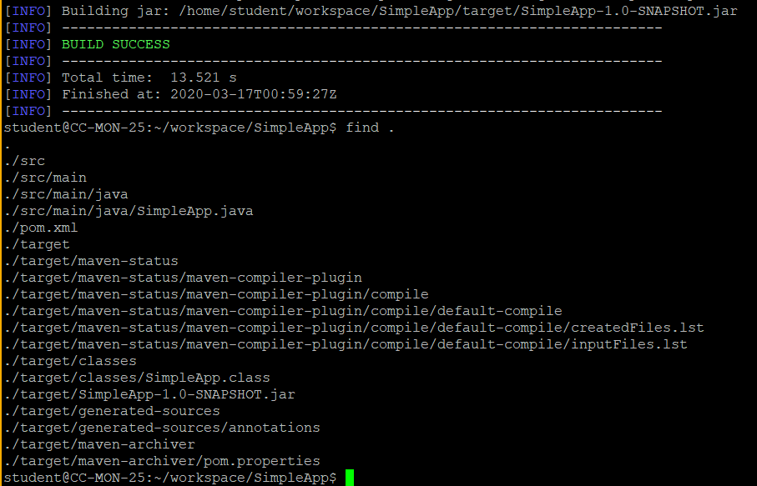

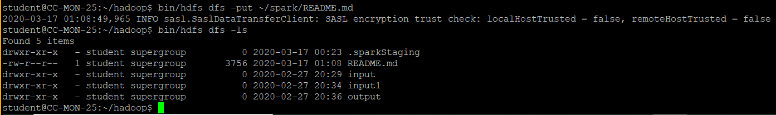

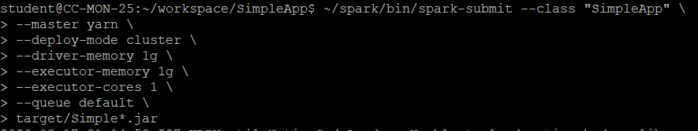

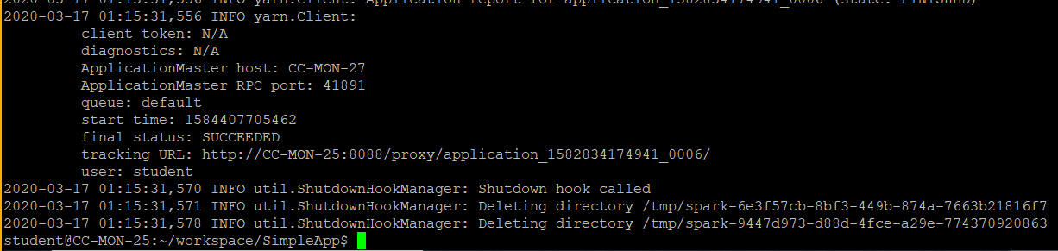

Spark Master UI:

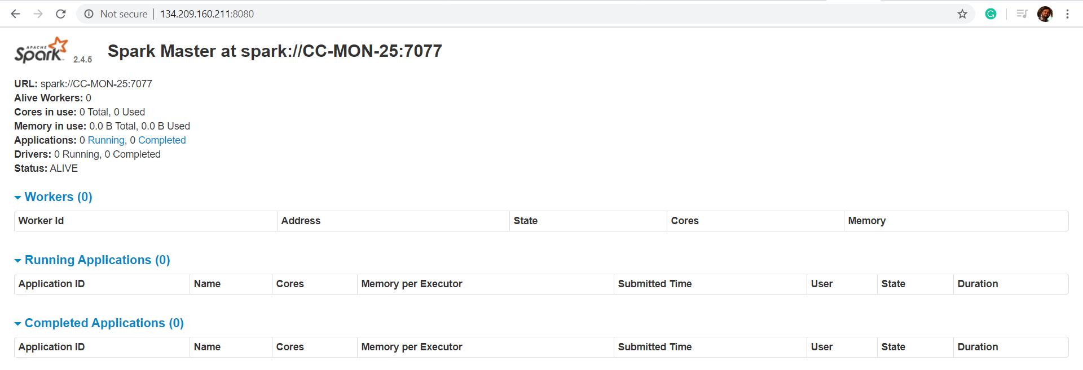

**Part 2: Developing Spark Programs**

As a part of this project, we will be working with the ‘**hetrec2011-lastfm-2k**’ data set. In particular, we will be working on the ‘**user_artists.dat**’ data file.

More details about the dataset can be found out here:

<https://grouplens.org/datasets/hetrec-2011/>

The task is to printout the **total listening counts of each artist**. Our program should print out the listening counts per artist in **descending order**. In the ‘**user_artists.dat**’ file, listening counts for each user-artist pair is indicated by the variable ‘**weight’**.

**Solution:**

‘**ListeningCount.java**’ program has been written to printout the **total listening counts of each artist**.

The program prints out the listening counts per artist in **descending order**.

Screenshot of the **Java program**:

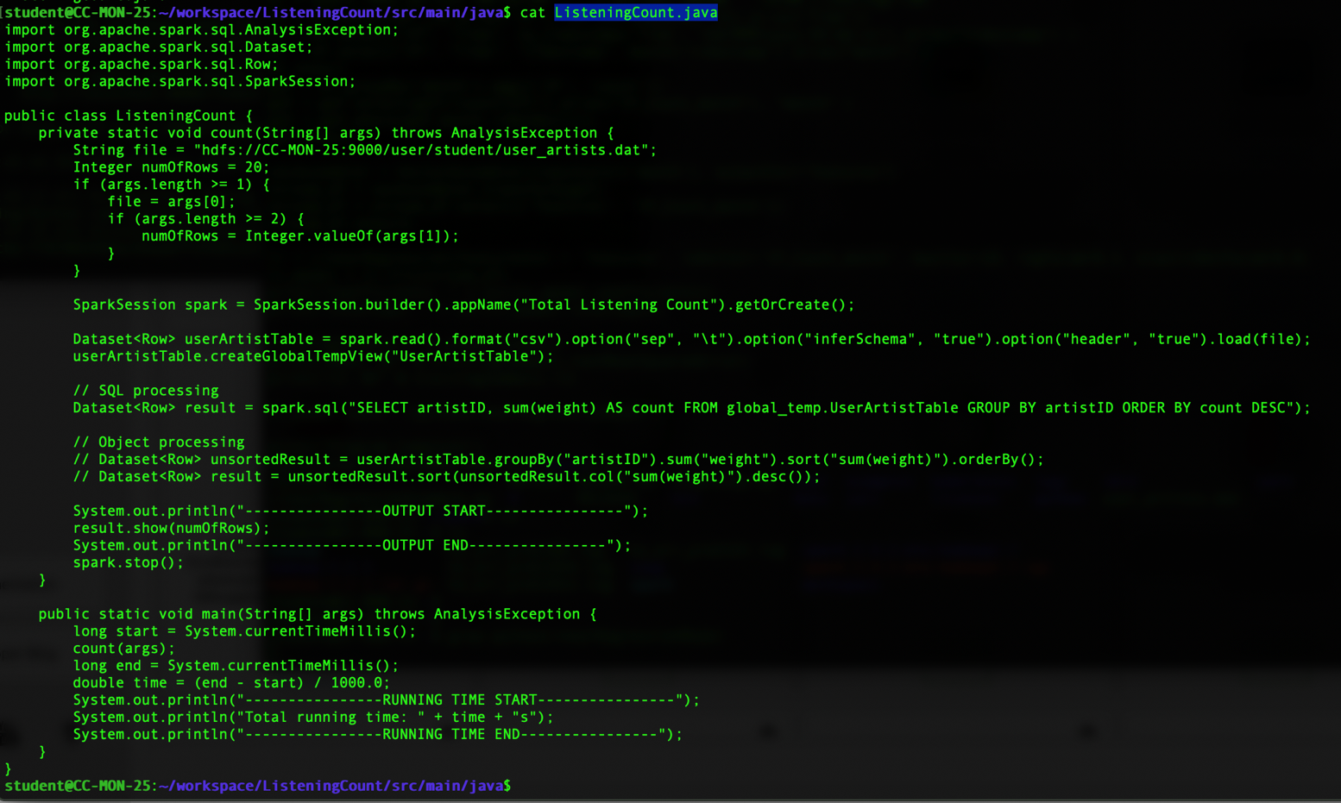

**Executing the program:**

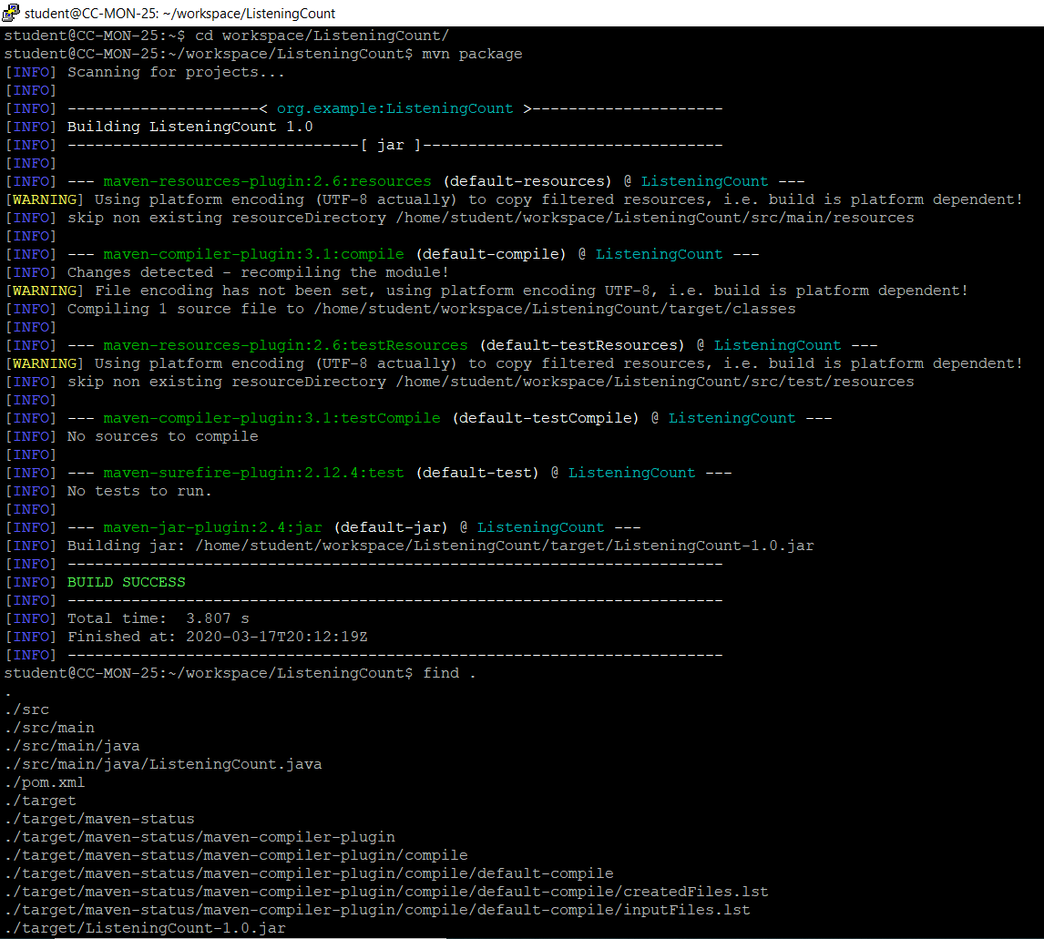

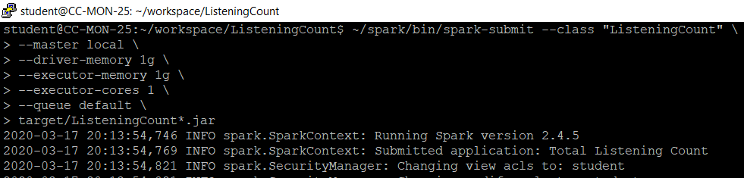

**Output:**

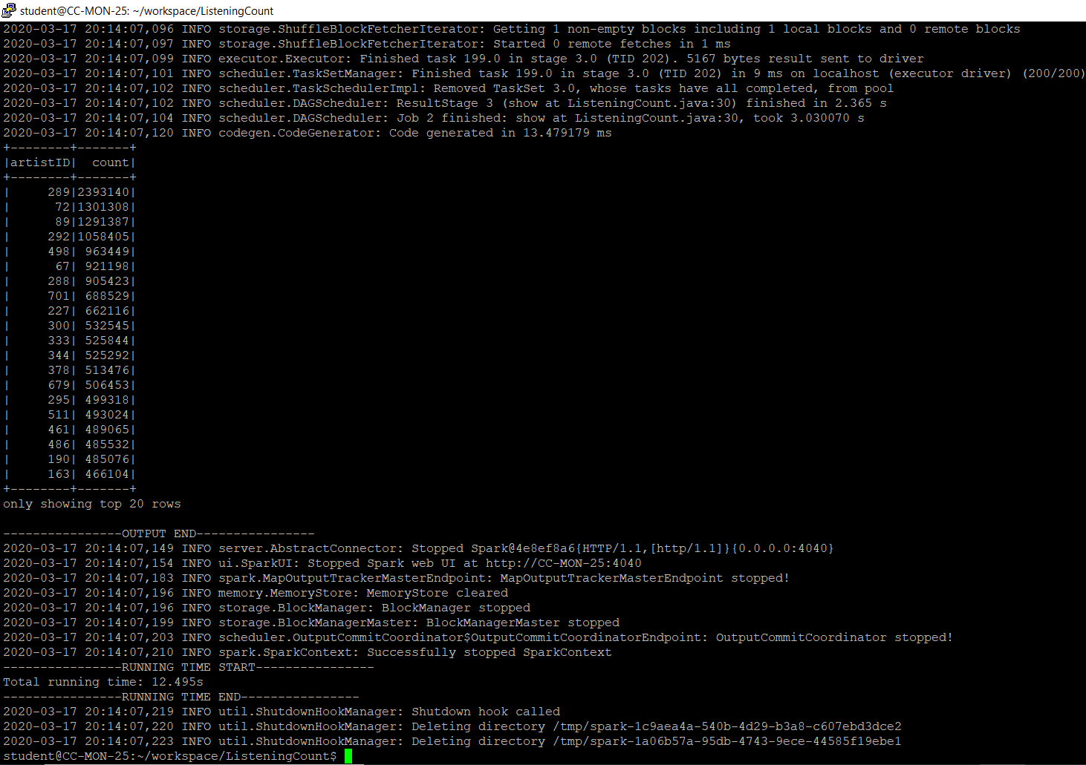

**Part 3: Developing Spark Programs 2**

As part of the project you will be working with the log data set which is provided in

access_log.zip in the Mini Project 1.

In this project, you need to translate a python program which is running locally to a Spark program,

which can be run on the Spark Cluster.

The python program is given within the project file, which is named

“**LinearRegressionExample.ipynb**” which can be opened by **jupyter notebook**.

The program predicts the trend of accessing the website by a simple linear regression.

What you need to do can be separate to the following:

1. Test the local program (provided in “**LinearRegressionExample.ipynb**”) on your own laptop by running a jupyter notebook, you can check:
2. Install Anaconda (an all-in-one python environment) for python 3.7:

<https://www.anaconda.com/distribution/>

1. Run Jupyter notebook:

<https://jupyter.readthedocs.io/en/latest/running.html#running>

**Solution:**

Anaconda (an all-in-one python environment) is installed for Python 3.7 and Jupyter notebook is run. Please see the screenshot below:

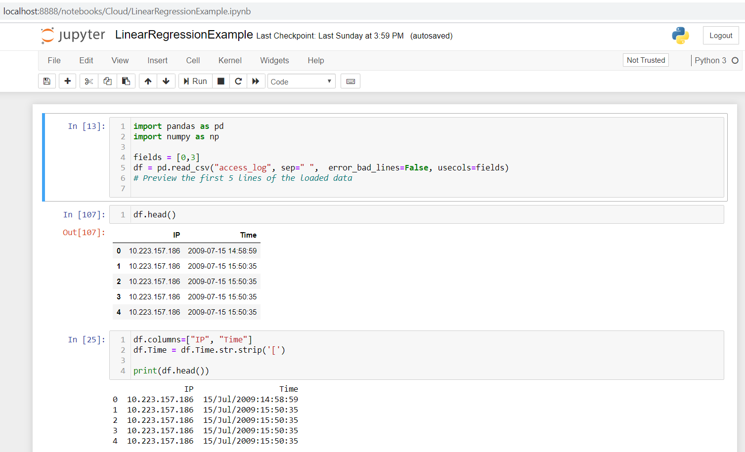

1. Setup and test your spark cluster with running any of the Spark environment on your cluster

(JAVA, Scala, or Python), reference: <https://spark.apache.org/docs/latest/quick-start.html>

**Solution:**

Spark cluster is setup and tested with Python-Spark environment. Please see the screenshot below:

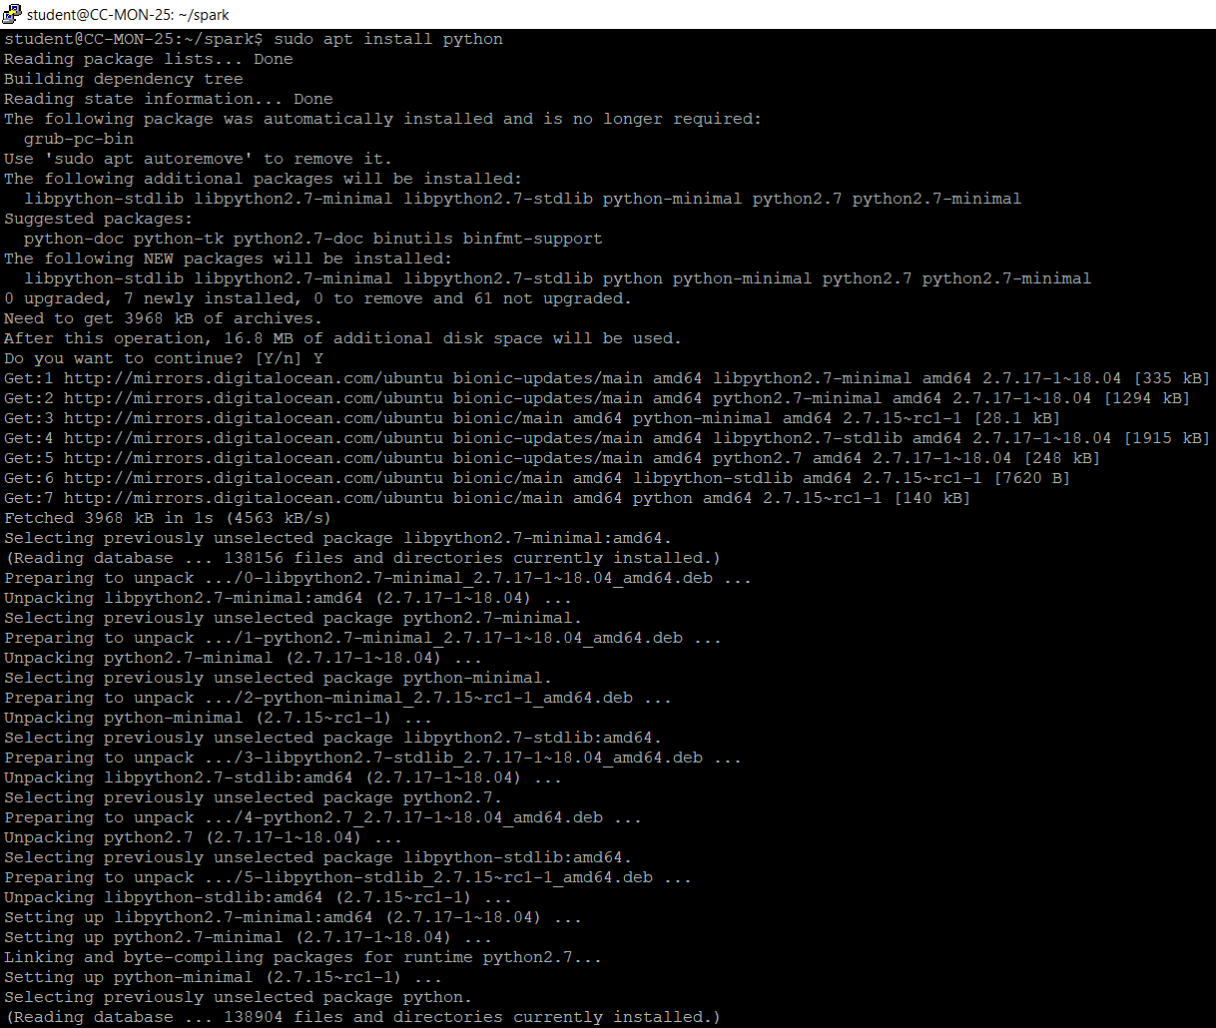

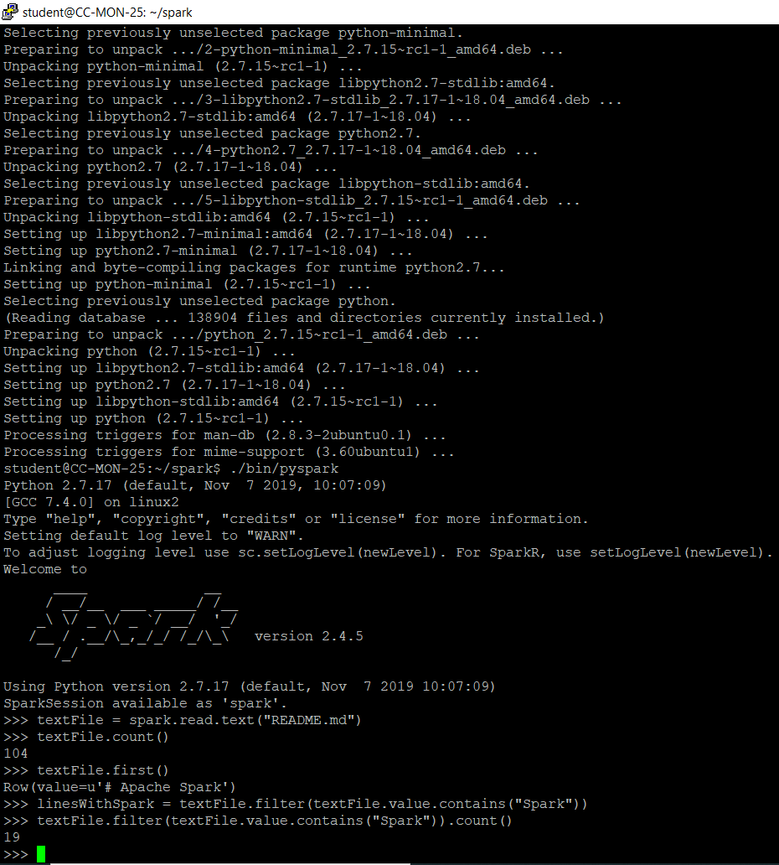

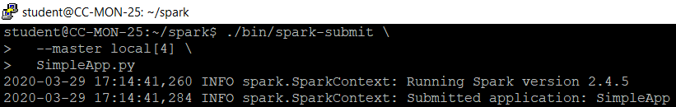

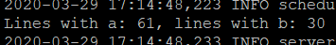

1. Translate the program into a Spark program, you can choose one of the languages you want to use, which can be JAVA, Scala, or Python. The program should include at least the four parts below:
2. Initiate the SparkSession (or SparkContext) running on the Spark cluster: <https://spark.apache.org/docs/latest/quick-start.html#self-containedapplications>
3. Load the “**access_log**” on HDFS into the Spark program as a DataFrame (DataSet):

<https://spark.apache.org/docs/latest/sql-data-sources-load-save-functions.html>

1. Group the access logs by the timestamp in month:
2. JAVA:

<https://spark.apache.org/docs/latest/api/java/index.html?org/apache/spark/sql/Dataset.html>

1. Scala:

<https://spark.apache.org/docs/latest/api/scala/index.html#org.apache.spark.sql.Dataset>

1. Python:

<https://spark.apache.org/docs/latest/api/python/pyspark.sql.html#pyspark.sql.DataFrame>

1. Use the Spark MLlib to do the simple linear regression on the grouped result and save the model to an output file:

<https://spark.apache.org/docs/latest/mllib-linear-methods.html#linear-least-squares-lasso-and-ridge-regression>

**Solution:**

Program translation (Python to Spark) - Please see the screenshots below:

The program contains the following parts:

1. SparkSession initiated and run on Spark cluster. (Line 1)
2. “**access_log**” file loaded on HDFS into the Spark program as a DataFrame (DataSet). (Line 9)
3. The access logs are grouped by the timestamp in month. (Line 12-25)
4. Simple Linear Regression done on the grouped result and the model is saved to an output file -

**pythonLinearRegressionModel.** (Line 27 – 36)

**Program Screenshot**

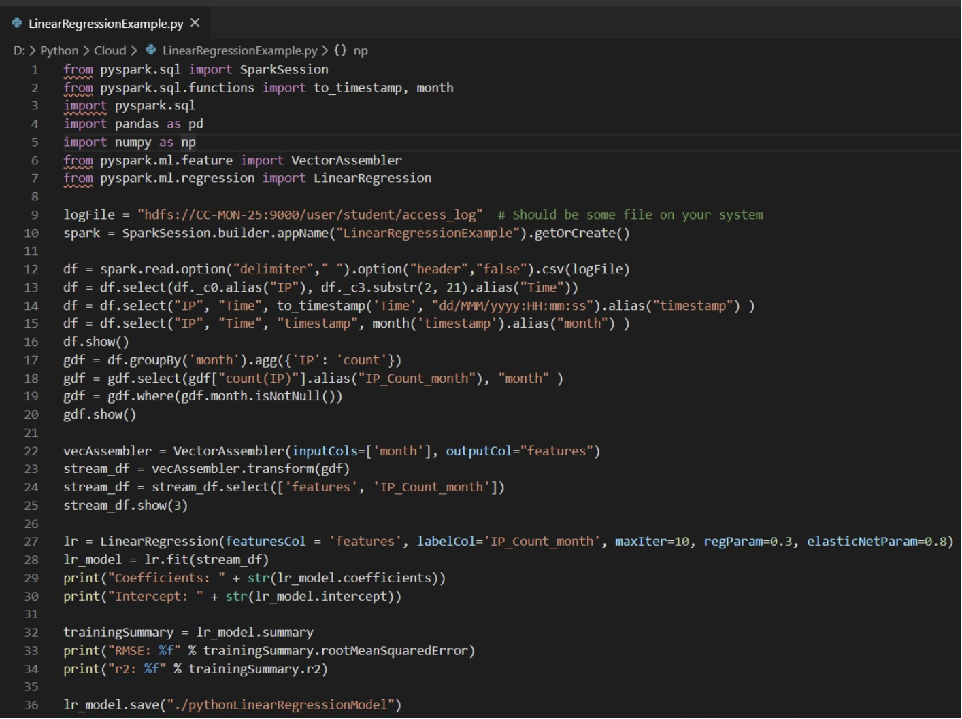

**Program Execution:**



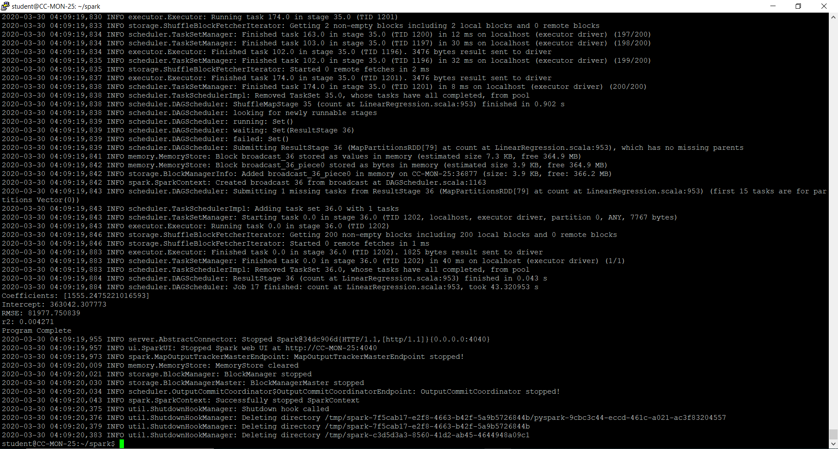

**Checking for the output file:**

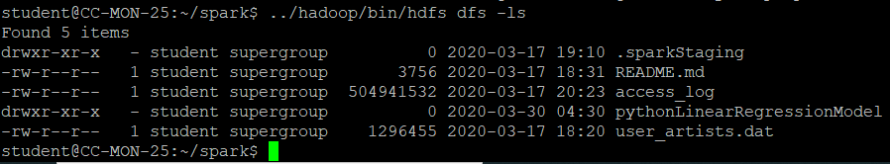

**Output:**

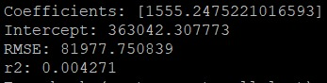

**Parquet Output**

